- RUN THE “Koza_temporary.exe” software.

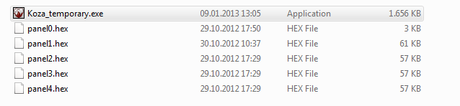
- Open the panel1.hex file from the file open menu.
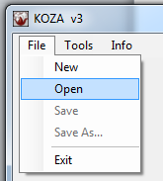

- Panel1.hex includes your destination information. Click the destination editor tab. Then click over the current text to change the destination. Write your destination here.

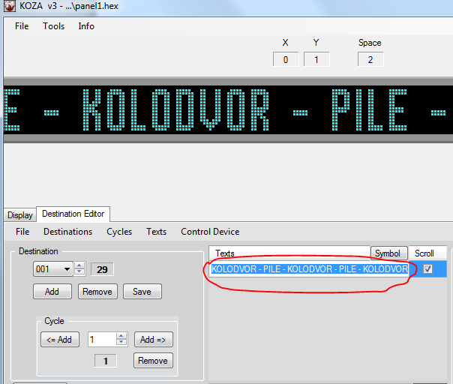

- You can use alot of destination. For example. The bus goes to D point from the A point ( B and C point are between A and D) . Your first destination should be like this “ A-B-C-D”

İf the bus doesnt use the same route on the way back, you should use another destination. For example bus goes to G point from the D point (E and F point are between D and G). İn this situation click the add and write 2. Write your text into the text area.

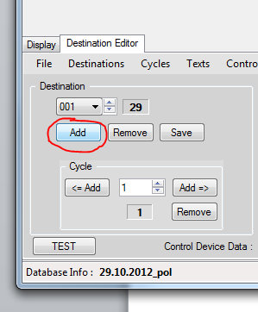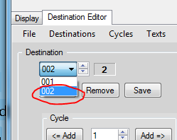

Driver is going to select “1” from the control panel on the “A to D way”, and select “2” on the “D to G point.
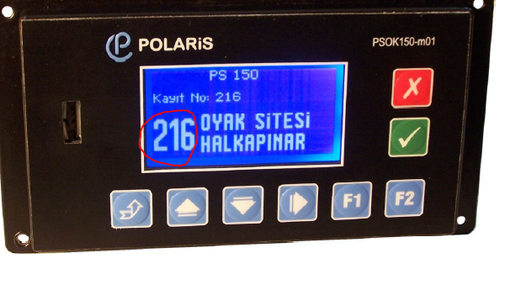
NOTE: Panel1.hex which sent to you includes about 27 destination. You should remove them and add yours.

- Save the file with the same name ( Dont chance any panelx.hex name. Keep them with orijinal names).

- Panel2.hex and panel4.hex the destination numbers shown below. İf you want to cahnge them apply 1-2-3 commands.

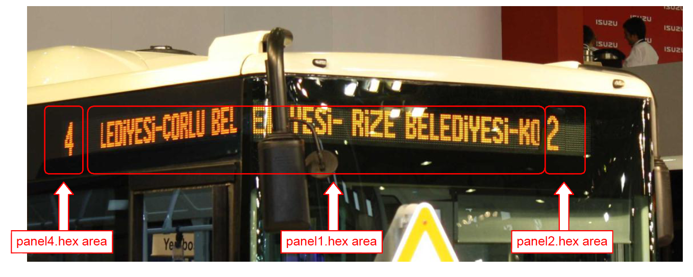

Panel3.hex for the rear destination board. İf you dont have a rear destination board just delete the panel3.hex.
Panel0.hex the file for includes all the information. You dont need to change it.

- Panel2.hex and panel4.hex the destination numbers shown below. İf you want to cahnge them apply 1-2-3 commands.

- Save the all panel.hex files into a file. Save the file into a usb.

- İnsert the usb to the control panel and load all destinations. (if control panel dosnt see the usb, change the usb with another usb. Sometimes there may be some crashes due to the version of the usb.

- You can find detailed informations in the pdf files which sent to you about the “koza” software and the control panel device.

